# CSC 431 StrategyGame Software Requirements Specification (SRS)

1. **TTTBG**™

|  |  |
| --- | --- |
| Andrew Gonzalez | Project Manager, Developer |
| Salahuddin Bawaney | Developer |
| Micheal Bowermaster | Developer |
| Micheal Taylor | Developer |
| Giuseppe Cannavo | Lead Game Designer, Artist, Developer |
| Renel Desir | Developer |

# Version History

|  |  |  |  |
| --- | --- | --- | --- |
| Version | Date | Author(s) | Change Comments |
| 1.0 | 2/19/2020 | Julio Perez | Removed References in Source Scenario. That information could be added in Design Document. |
|  |  |  |  |
|  |  |  |  |
|  |  |  |  |

# Table of Contents

1. System Requirements 6

1.1 Functional Requirements 6

1.1.1 Requirement Title 6

1.2 Non-Functional Requirements 6

1.2.1 Requirement Title 6

2. System Constraints 7

2.1 Tool Constraints 7

2.1.1 Requirement Title 7

2.2 Language Constraints 7

2.2.1 Requirement Title 7

2.3 Platform Constraints 7

2.3.1 Requirement Title 7

2.4 Hardware Constraints 7

2.4.1 Requirement Title 7

2.5 Network Constraints 7

2.5.1 Requirement Title 8

2.6 Deployment Constraints 8

2.6.1 Requirement Title 8

2.7 Transition & Support Constraints 8

2.7.1 Requirement Title 8

2.8 Budget & Schedule Constraints 8

2.8.1 Requirement Title 8

2.9 Miscellaneous Constraints 8

2.9.1 Requirement Title 8

3. Requirements Modeling 10

3.1.1 Requirement Title 10

4. Evolutionary Requirements 11

4.1 Functional Requirements 11

4.1.1 Requirement Title 11

4.2 Non-Functional Requirements 11

4.2.1 Requirement Title 11

# Table of Tables

<Generate table here>

# Table of Figures

<Generate table here>

### System Requirements

#### Functional Requirements

*< List all functional requirements in the following example format >*

##### Requirement Title

|  |  |
| --- | --- |
| ID | FR1 |
| Title | Main Menu |
| Description | A menu that appears upon launching the game. Has interactive buttons, such as Play to select a mode, Deck to edit or create a new deck of cards, Exit to exit the application, and Settings to change video, audio, and other game settings. There will be music playing, background art, and feedback (visual/aural) for user interactions (i.e. button changes color upon hovering over it). |
| Source Scenario |  |
| Priority | 0 |
| Precondition(s) | Have application open up in browser |
| Basic Flow | 1)The user selects an option using the keyboard or the mouse.  2)The system determines what action to follow, by either starting a game, opening another menu, a deck editor, or quitting the game. |
| Postconditions(s) | Icons present for easy navigation back to the main menu |
| Use Case Diagram | <Link or number, if present> |

|  |  |
| --- | --- |
| ID | FR2 |
| Title | Networking |
| Description | In order to send and receive data, the game will need to interact with the user, by nature of the game, the other player can’t know everything from the other player, so it must be made sure that only certain information is sent and received |
| Source Scenario |  |
| Priority | 1 |
| Precondition(s) | Have main gameplay mechanics set down |
| Basic Flow | 1)The user makes inputs and changes the states of the game  2) The system sets the game states depending on the current state of the game and the inputs the player decides to make. |
| Postconditions(s) | Continuous syncing until the game ends. |
| Use Case Diagram | <Link or number, if present> |

|  |  |
| --- | --- |
| ID | FR3 |
| Title | Player control |
| Description | In order to move the board pieces through the board, the player will need a controller, probably a cursor, to move the pieces around the field. |
| Source Scenario |  |
| Priority | 0 |
| Precondition(s) | The board field and pieces that interact and rest on the board. |
| Basic Flow | 1)The user presses buttons designated to movement  2)The system moves the cursor in a cardinal direction from where the player pressed the button  3)If the player presses the confirm button, the system selects the tile the cursor is resting in. |
| Postconditions(s) | The board piece performs an action |
| Use Case Diagram | <Link or number, if present> |

|  |  |
| --- | --- |
| ID | FR4 |
| Title | Game Logic and Rules |
| Description | The board game must follow a predetermined set of rules, including conditions for victory or to perform a particular action.  The game’s logic and source code must prevent a player from being able to break or subvert these rules.  Actions that are within the rules are legal actions, those against are illegal actions. |
| Source Scenario |  |
| Priority | 1 |
| Precondition(s) | The player initiates an action on the board game. |
| Basic Flow | Once the player has initiated an action or event on the board game, before it can be synced and therefore viewable by the other players, the client side or server must check whether it is a legal or illegal move or action. If it is illegal, it will not sync to the server. If the action is legal, the network will sync, and the game will carry on.  1) The player initiates an action or event on the board game.  2) The client or server must check if the move made by the player is legal or illegal.  3) If the action is illegal, the network will not sync to the server. If the action is legal, the network will sync. |
| Postconditions(s) | There will be visual feedback indicating an action as an illegal move to the player, however, the other players will have no knowledge as the action did not sync with the server nor was transmitted to them through the network. |
| Use Case Diagram | <Link or number, if present> |

|  |  |
| --- | --- |
| ID | FR5 |
| Title | Player Action History |
| Description | A visual record of each player’s actions, such as card movement, combat, terrain changes, and morphing. This can be used by players to backtrack all actions taken by them and their enemy player. |
| Source Scenario |  |
| Priority | 5 |
| Precondition(s) | Player actions must be stored in a database |
| Basic Flow | 1)The player can either click a button on the screen or press and designated button  2)The system will show a record of the most recent actions taken in the game, in the form of an action queue. |
| Postconditions(s) | The history minimizes once the cursor moves from it |
| Use Case Diagram | <Link or number, if present> |

|  |  |
| --- | --- |
| ID | FR6 |
| Title | Board |
| Description | A X by X tile-based grid that defaults with starting terrains and changes provided user actions. Cards are placed on tiles along the grid with the cards interacting with the terrain type and other cards. |
| Source Scenario |  |
| Priority | 0 |
| Precondition(s) | Board manager must keep track of tile information |
| Basic Flow | The board persists throughout gameplay and from its default states changes based on player actions.  1) The board persists throughout gameplay.  2) From the default state, the board changes depending on player actions. |
| Postconditions(s) | Cards, user options, and other visual/aural feedback |
| Use Case Diagram | <Link or number, if present> |

|  |  |
| --- | --- |
| ID | FR7 |
| Title | Deck |
| Description | A deck of Y Monster Cards. To summon a monster, a player spends an amount of Energy Points equal to a value shown on the Monster Card.  At the start of the game, each player draws X cards. At the start of a player’s turn, that player must draw 1 card from the Deck.  Outside of a game, players can select what Monster Cards will be in their deck and how many of each type. |
| Source Scenario |  |
| Priority | 0 |
| Precondition(s) | Energy Point System, Monster Card Info, Card Art, Game Logic and Rules |
| Basic Flow | Players will build, modify, and select a Deck before the start of a game, through the Main Menu. At the start of the game, each Player will draw X Cards and the Deck size will decrease by X. At the start of each Player’s turn, that Player will draw a Card. Each time a Player draws a Card, an animation will show the Card move from the Deck to the Player’s Hand. The Player will then select a Card from his hand to set on the Board and an animation will play as the Card is set on the board.   1. 1) Players build, modify, and select their deck before the game begins in the Main Menu. 2. 2) At the start of the game, each player draws X cards. The deck size will decrease by this X amount as well. 3. 3) The player draws a card at the start of their turn. 4. 4) An animation plays where the card moves from the Deck to the Player’s Hand. 5. 5) The Player will select a card from their hand to set on the board. 6. 6) An animation will play as the card is set on the board. |
| Postconditions(s) | Player Control, Board |
| Use Case Diagram | <Link or number, if present> |

|  |  |
| --- | --- |
| ID | FR8 |
| Title | Energy Point System |
| Description | Energy Point System will be used to summon Monster Cards from Player Hand and activate Monster Card effects. Energy Point current and Energy Point maximum start at the same value every turn but only the Energy Point current decreases during the turn. The Energy Point maximum will only increase throughout the game till the end of the game. Both the current and maximum will be set to 4 at the start of a game. |
| Source Scenario |  |
| Priority | 0 |
| Precondition(s) | Monster Card Info, Game Logic and Rules |
| Basic Flow | Each player will start with 4 Energy Points. At the start of a Player’s turn, the Energy Point current and Energy Point maximum will be set to the Energy Point maximum+1. When a Player summons a Monster Card, the Energy Point current will decrease by the Monster Card cost. If the Player activates a Monster Card effect, the Energy Point current will decrease by the cost of the effect.  1) Each player starts with 4 Energy Points. At the start of every turn, the Energy Point current value and maximum value will be set to the Energy Point maximum value, plus one.  2) When a player summons a Monster Card, the Energy Point current value will decrease by the Monster Card cost. 3) If the player activates a Monster Card effect, the Energy Point current value will decrease by the cost of the effect. |
| Postconditions(s) | Player Control, Board, Deck |
| Use Case Diagram | <Link or number, if present> |

#### Non-Functional Requirements

*< List all non-functional requirements in the following example format >*

##### Requirement Title

|  |  |
| --- | --- |
| ID | NFR1 |
| Title | Modelling |
| Description | Since the game is 3D, it will need 3D meshes to work with, for at the very least model basic board pieces and the board. |
| Source Scenario | Blender, or any 3D modelling program |
| Priority | 3 |
| Applicable FR(s) | FR3. |

|  |  |
| --- | --- |
| ID | NFR2 |
| Title | Music and sound effects |
| Description | To create satisfying game feedback to the player, there will need to be sound effects created that trigger every time the user selects or interacts with the game, as well as background music |
| Source Scenario | Any Digital Audio Workstation. |
| Priority | 4 |
| Applicable FR(s) | FR3, FR1. |

|  |  |
| --- | --- |
| ID | NFR3 |
| Title | Language |
| Description | Multiple languages so different kinds of players can play the game, accessible through the main menu to allow a better user experience. |
| Source Scenario | Translation Skills. |
| Priority | 5 |
| Applicable FR(s) | FR1, FR3. |

|  |  |
| --- | --- |
| ID | NFR4 |
| Title | Visual Feedback for Errors |
| Description | When illegal moves are performed by the player, the player will be shown visual feedback to show they have attempted to perform an illegal move. The visual feedback could be in the form of a red glow around a card or on a grid on the board. |
| Source Scenario | C# |
| Priority | 4 |
| Applicable FR(s) | FR2, FR4. |

|  |  |
| --- | --- |
| ID | NFR5 |
| Title | Animations & Particle Effects |
| Description | Various animations and particle effects will provide feedback for player interaction (ex: cursor hovering over card to allow user to see card info.), combat results (ex: card destruction or merging), and other changes in the game state (ex: victory and defeat). |
| Source Scenario | Unity, Blender, or other animation/particle programs. |
| Priority | 3 |
| Applicable FR(s) | FR1, FR3, FR6. |

|  |  |
| --- | --- |
| ID | NFR6 |
| Title | Game Manager |
| Description | Core manager of the game flow, states, and interactions. Any change to the game is recorded within the manager, such as the location of cards, the number of cards present in a player’s hand, and the health & mana of the players. |
| Source Scenario | Unity C#. |
| Priority | 0 |
| Applicable FR(s) | FR3, FR4, FR5, FR6. |

### System Constraints

#### Tool Constraints

*< List all tool constraints in the following example format >*

##### Requirement Title

|  |  |
| --- | --- |
| ID | TC1 |
| Title | Unity |
| Description | The game must be created utilizing the Unity game development platform. |
| Priority | 0 |

* + - 1. **Language Constraints**

*< List all language constraints in the following example format >*

* + - * 1. **Requirement Title**

|  |  |
| --- | --- |
| ID | LC2 |
| Title | C# |
| Description | The game must use the C# programming language as its main source code language. |
| Priority | 0 |

* + - 1. **Platform Constraints**

*< List all platform constraints in the following example format >*

* + - * 1. **Requirement Title**

|  |  |
| --- | --- |
| ID | PC1 |
| Title | PC |
| Description | The game will be made available for PC users only. |
| Priority | 0 |

* + - 1. **Hardware Constraints**

*< List all hardware constraints in the following example format >*

* + - * 1. **Requirement Title**

|  |  |
| --- | --- |
| ID | HC1 |
| Title | Minimum Requirements to Run |
| Description | The game must be capable of running on any modern popular CPU/GPU. |
| Priority | 0 |

* + - 1. **Network Constraints**

*< List all network constraints in the following example format >*

* + - * 1. **Requirement Title**

|  |  |
| --- | --- |
| ID | NC1 |
| Title | Internet |
| Description | The game must be capable of running within an online server, and be playable with others using an internet connection. |
| Priority | 1 |

#### Deployment Constraints

*< List all deployment constraints in the following example format >*

##### Requirement Title

|  |  |
| --- | --- |
| ID | <a unique ID for the constraint, e.g., C1)> |
| Title | <Insert title> |
| Description | <A one or two sentence description> |
| Priority | <Priority from 0 (highest) – 5 (lowest)> |

#### Transition & Support Constraints

*< List all transition & support constraints in the following example format >*

##### Requirement Title

|  |  |
| --- | --- |
| ID | <a unique ID for the constraint, e.g., C1)> |
| Title | <Insert title> |
| Description | <A one or two sentence description> |
| Priority | <Priority from 0 (highest) – 5 (lowest)> |

#### Budget & Schedule Constraints

*< List all budget & schedule constraints in the following example format >*

##### Requirement Title

|  |  |
| --- | --- |
| ID | <a unique ID for the constraint, e.g., C1)> |
| Title | <Insert title> |
| Description | <A one or two sentence description> |
| Priority | <Priority from 0 (highest) – 5 (lowest)> |

#### Miscellaneous Constraints

*< List all miscellaneous constraints in the following example format >*

##### Requirement Title

|  |  |
| --- | --- |
| ID | <a unique ID for the constraint, e.g., C1)> |
| Title | <Insert title> |
| Description | <A one or two sentence description> |
| Priority | <Priority from 0 (highest) – 5 (lowest)> |

### Requirements Modeling

*< List all Use-case diagrams for the functional requirements in the following format>*

##### Requirement Title

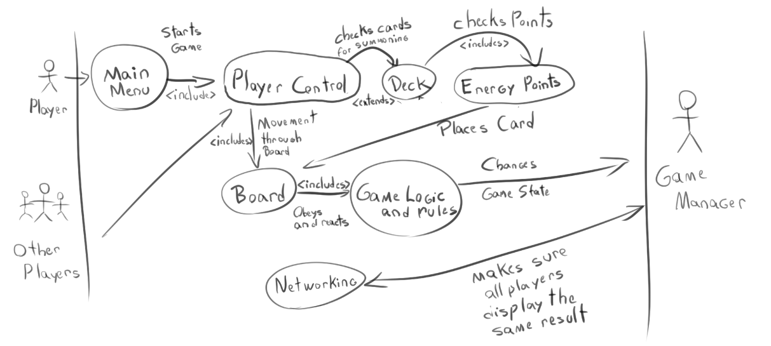

There is also a detailed list of the game states the game can enter (Determined by a Finite State Machine)

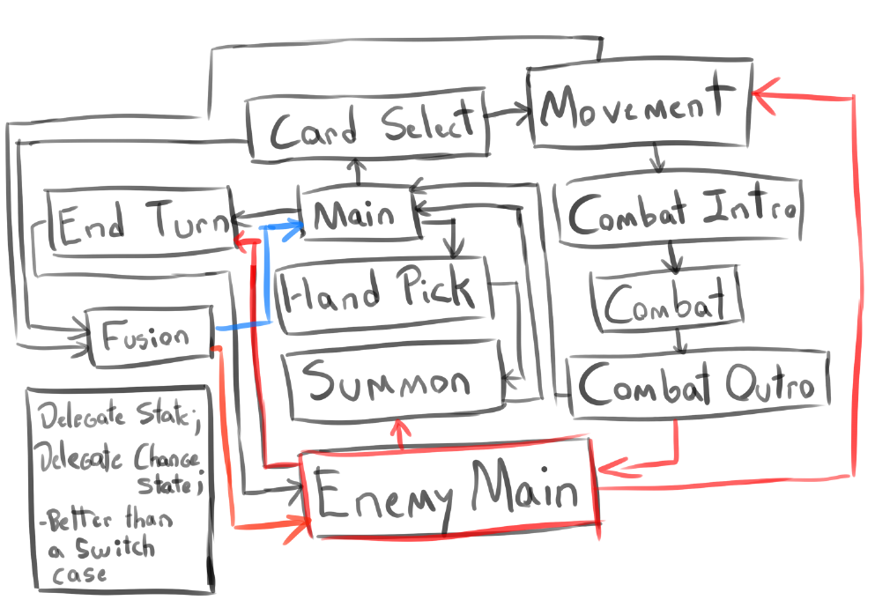

### Evolutionary Requirements

#### Functional Requirements

*< List all functional requirements in the following example format >*

##### Requirement Title

|  |  |
| --- | --- |
| Title | <Insert title> |
| Description | <A one or two sentence description> |
| Priority | <Priority from 0 (highest) – 5 (lowest)> |
| Precondition(s) | <What needs to happen before> |
| Postconditions(s) | <What happens as a result> |
| Use Case Diagram | <Link or number, if present> |

#### Non-Functional Requirements

*< List all non-functional requirements in the following example format >*

##### Requirement Title

|  |  |
| --- | --- |
| Title | <Insert title> |
| Description | <A one or two sentence description> |
| Priority | <Priority from 0 (highest) – 5 (lowest)> |
| Applicable FR(s) | <Which functional requirement(s) is this applicable to?> |